Name_____________________________________________ Pd_______ Date_________________________________ Section 1.E.3b
Squares to Stairs Pattern
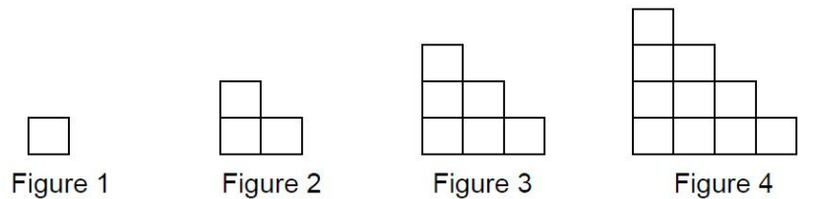

- How do you see the shapes growing? You can use words, colors, etc. to explain.

- Draw Cases 5 and 6.

- Make a table with the case number as the INPUT and the number of squares as the OUTPUT.

- What pattern do you see in the OUTPUTS?

- How many squares would be in Case 10? In Case 50?

- Write the function rule for the squares to stairs pattern.

