Name_____________________________________________ Pd_______ Date_________________________________ Section 1.E.3a
Nonlinear Patterns
- Any function that does NOT have a constant rate of change is NONLINEAR.
- Most common nonlinear functions we will see this year are QUADRATIC and EXPONENTIAL.
- Instead, they have different patterns that we can recognize.

Quadratic Function Tables Exponential Function Tables
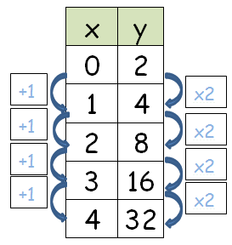
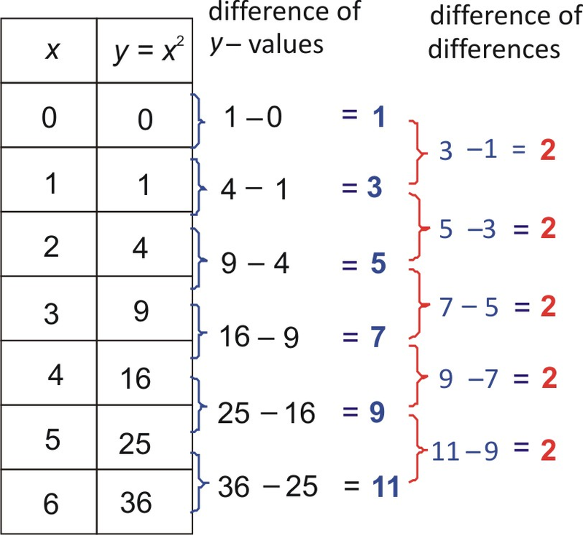

Growing Shapes Pattern
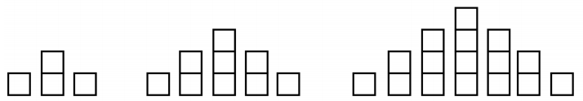
Case 1 Case 2 Case 3

- How do you see the shapes growing? You can use words, colors, etc. to explain.

- Draw Cases 4 and 5.

- Make a table with the case number as the INPUT and the number of squares as the OUTPUT.

- What pattern do you see in the OUTPUTS?

- How many squares would be in Case 10? In Case 50?

- Write the function rule for the growing shapes pattern.

